CPE301 – SPRING 2019

Design Assignment 2

Student Name: John Duriman

Student #: 5002373995

Student Email: duriman@unlv.nevada.edu

Primary Github address: https://github.com/johnduriman/pirahnaplant.git

Directory: pirahnaplant/Design Assignments/DA1B/

1. **COMPONENTS LIST AND CONNECTION BLOCK DIAGRAM w/ PINS**

Only Atmel Studio was used for this assignment

1. **INITIAL/MODIFIED/DEVELOPED CODE OF TASK 1/A**

None

1. **DEVELOPED MODIFIED CODE OF TASK 2/A from TASK 1/A**

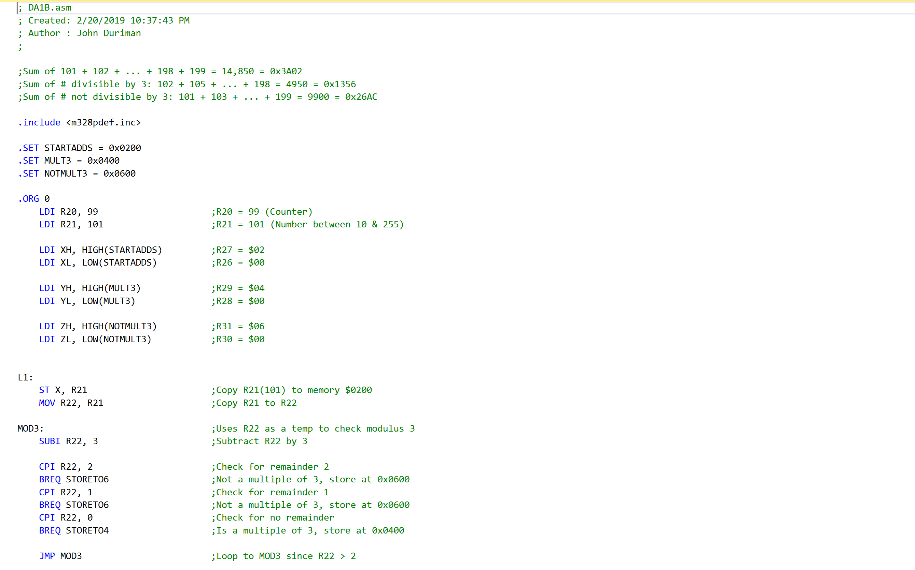

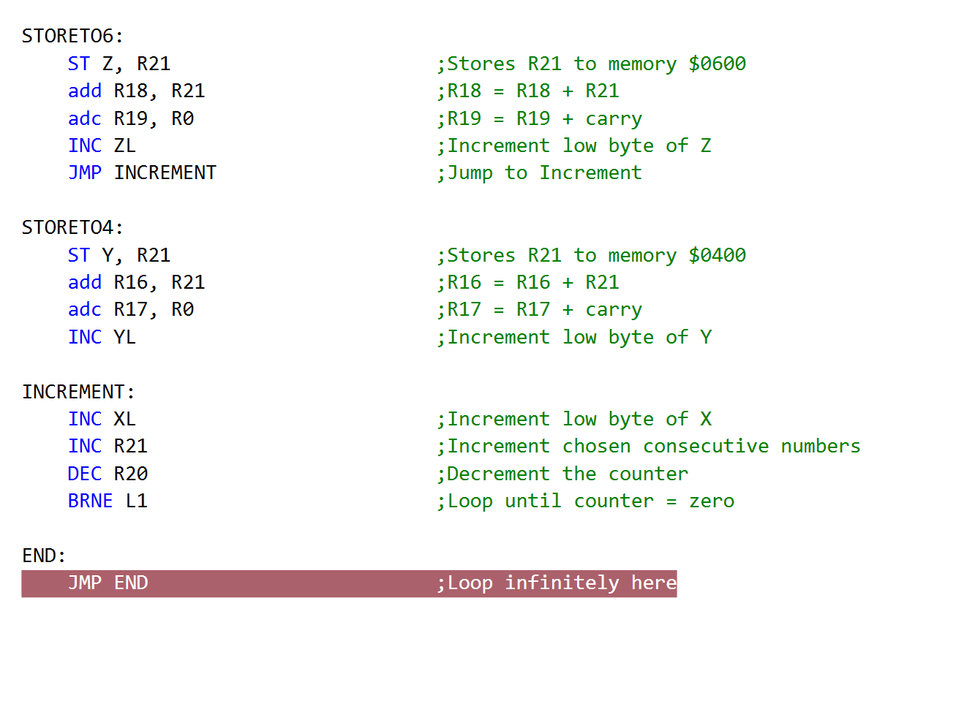

1. **SCHEMATICS**

Use fritzing.org

1. **SCREENSHOTS OF EACH TASK OUTPUT (ATMEL STUDIO OUTPUT)**

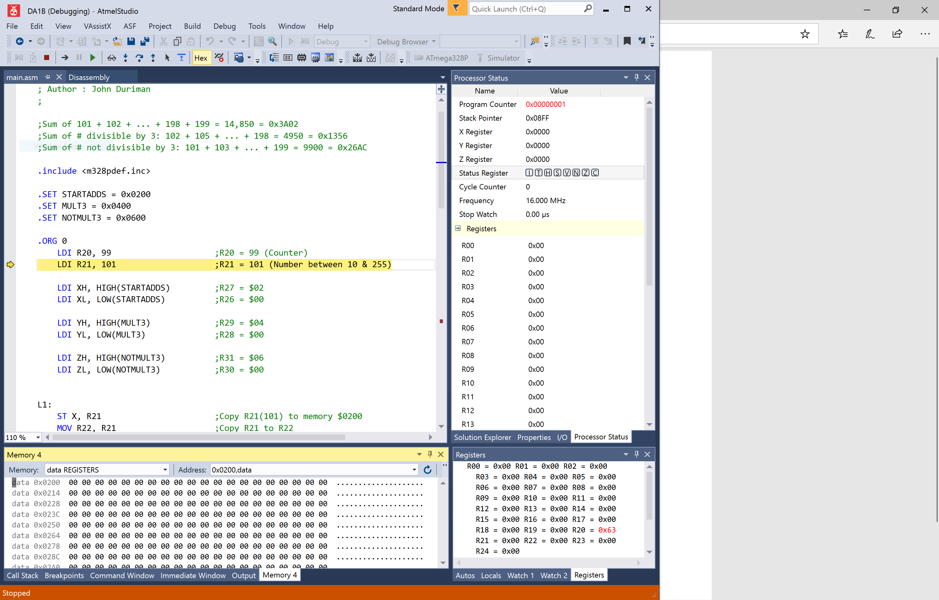

Task 1: This is a screenshot in the beginning of debugging where the 0x0200 is still empty and no numbers are stored yet

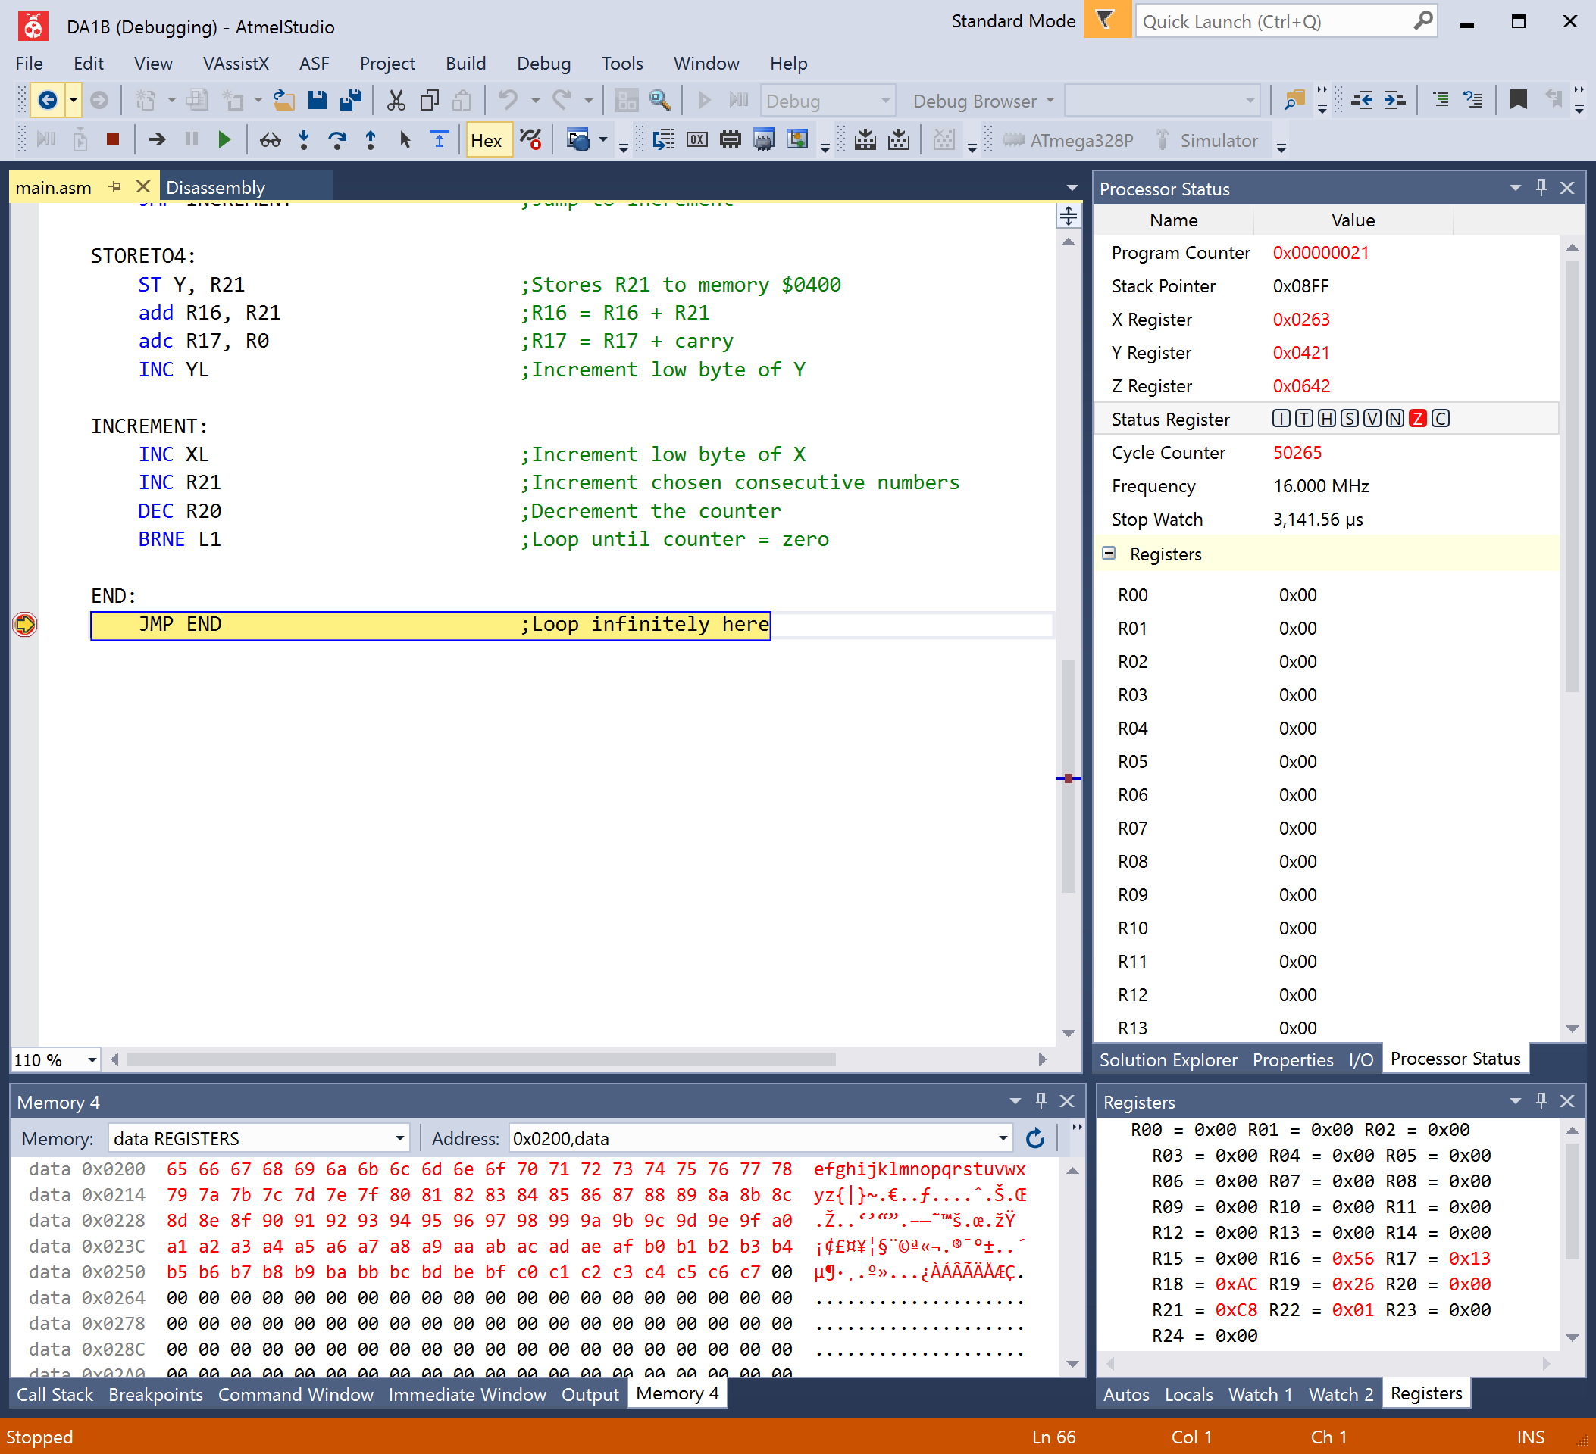

Task 1: Here is a screenshot of what happened after the debugging. The numbers are consecutive starting from $65 (101) all the way to $C7 (199)

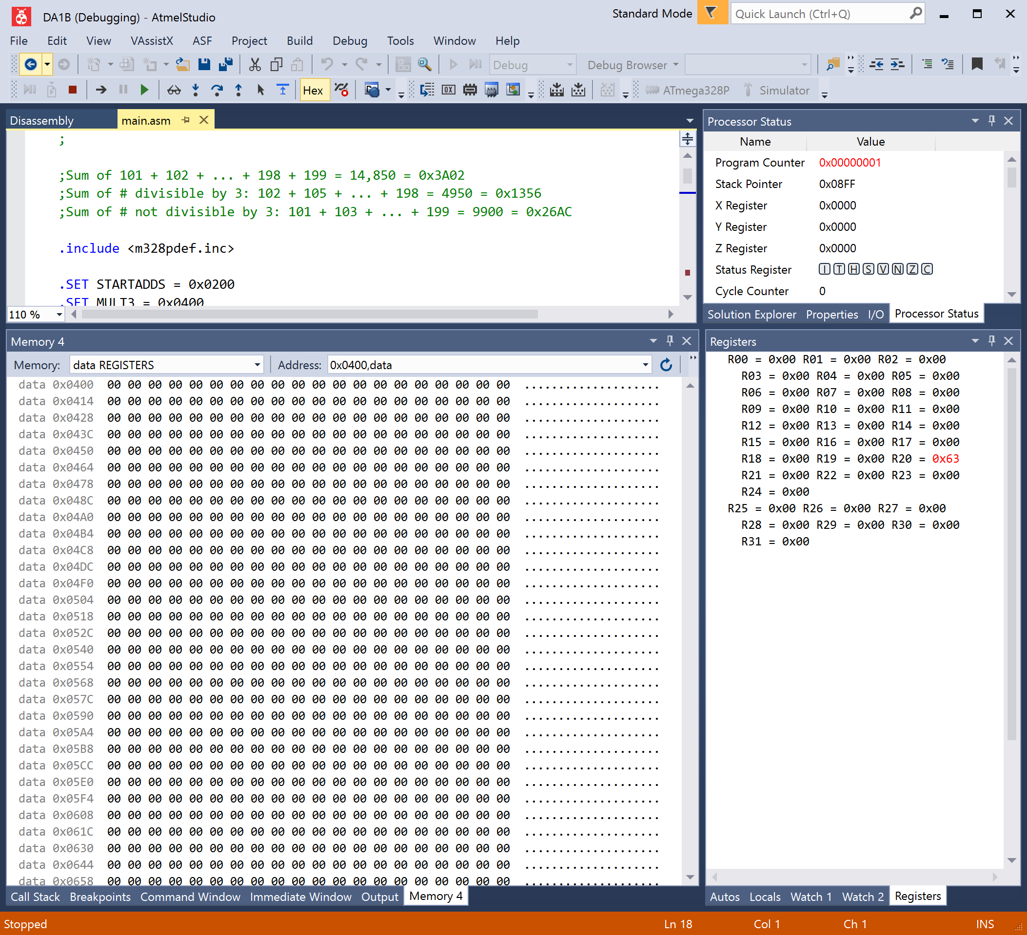

Task 2: The data registers are still empty in the beginning of debugging.

Task 3: The registers holding the sum of 0x0400 (R17:R16) and 0x0600 (R19:R18) are still empty.

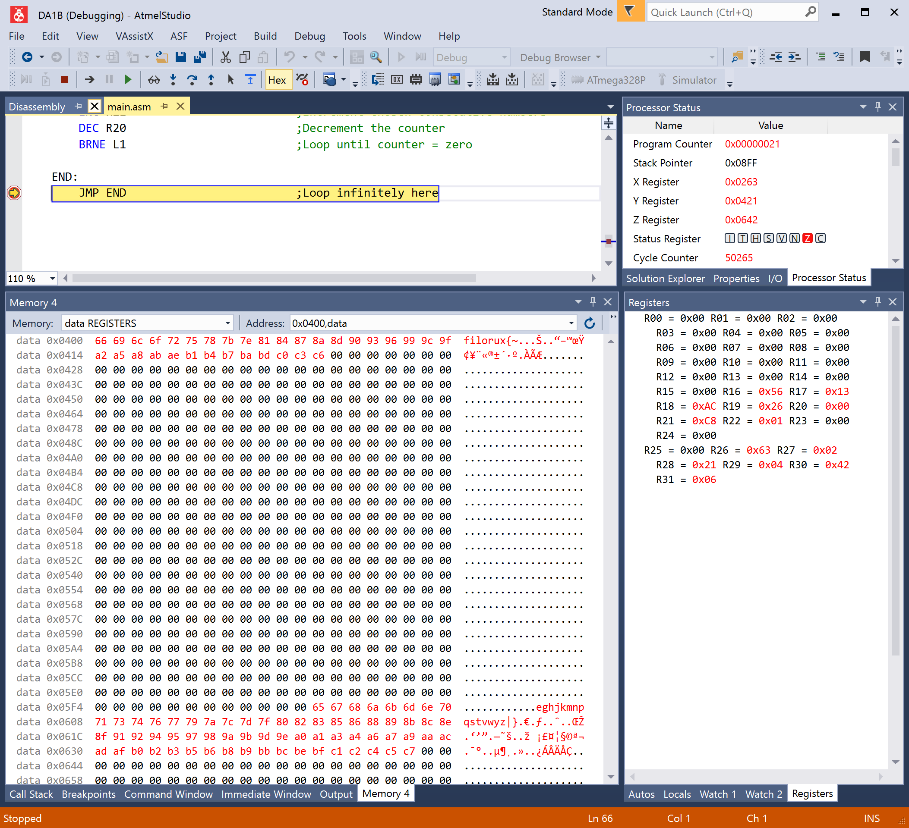

Task 2: Values at the end of debugging. All values not divisible by 3 are stored in 0x0600 and forward, while those divisible by 3 are stored in 0x0400.

Task 3: The registers holding the sum of 0x0400 (R17:R16) when combined is 0x1356, and 0x0600 (R19:R18) is 0x26AC.

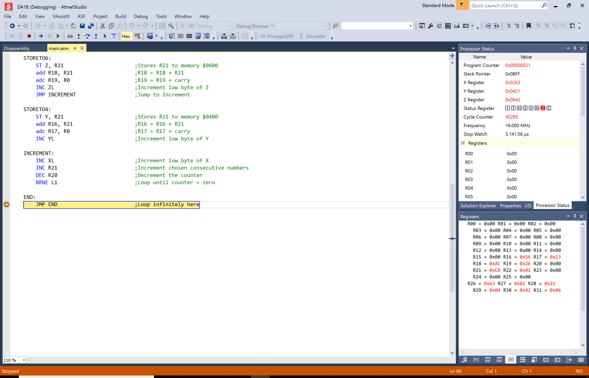

1. **SCREENSHOT OF EACH DEMO (BOARD SETUP)**

None

1. **VIDEO LINKS OF EACH DEMO**

None

1. **GITHUB LINK OF THIS DA**

https://github.com/johnduriman/pirahnaplant.git

**Student Academic Misconduct Policy**

<http://studentconduct.unlv.edu/misconduct/policy.html>

“This assignment submission is my own, original work”.

John Duriman